Table of Contents

Table of Contents 2
Introduction 2
Key 3
Off Page SEO 3
Ahrefs 5
Competitors 6
Backlinks 8
Google My Business 11
Detailed Competitor Analysis 13
Social Media 16
Summary and Conclusions 20
Areas for Improvement 20
Off Page 20
Competitors 21
Social Media 22
References and resources 22

Introduction
A Competitor Audit is the process of comparing your business and website to that of your competitors, with a specific focus on offpage factors such as backlinks and referring domains.

We choose 4 main competitors for comparison, based on your suggestions as well as our research into the SEO metrics of the particular companies’ websites. Sometimes the competitors we choose may differ from the ones you suggest - this may be because the competitors you suggest had a weak online presence, or were too much larger than you to provide a useful comparison.

The bulk of this audit is found in the Detailed Competitor Analysis. It is a separate document which contains hundreds of data points, but we summarise the main findings of the analysis in this document.

We additionally look at social media presence. We judge this based on a variety of factors from follower count to activity and engagement. The findings of this section pair well with the suggestions of the Content Strategy of the Content Audit.

This audit should be used to inform offpage SEO goals from backlink acquisition to social media to strategies to adjust your business to your competitors’ strengths and weaknesses.

Key

Green - Done well / trivial room for improvement
Orange - Done poorly / room for improvements
Red - Current state is detrimental to overall SEO / completely unimplemented
Blue - Our recommendation

Off Page SEO
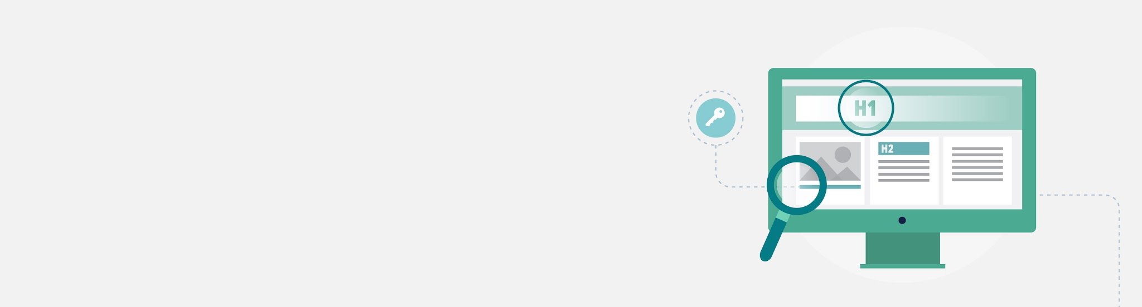
lOFF PAGE SEOl
Search engine ranking factor survey data has shown that getting external links is the single most important objective for attaining high rankings. This stems from the idea that external links are one of the hardest metrics to manipulate and thus, one of the best ways for search engines to determine the popularity of a given web page. This idea was first used by the early search engine Alta Vista and later improved upon by Google.

Google first made its mark by introducing the Stanford community to PageRank (an algorithm developed by Google co-founder Larry Page). This algorithm counted hyperlinks as votes for popularity. The pages that had the most links pointing at them were considered the most popular. When they were deemed relevant for a particular query, the most popular and relevant pages would become the first pages listed in Google's results. Although this algorithm is much more complex today, it still likely includes the notion of external links as votes.

Basically the more quality backlinks you have the higher you rank.
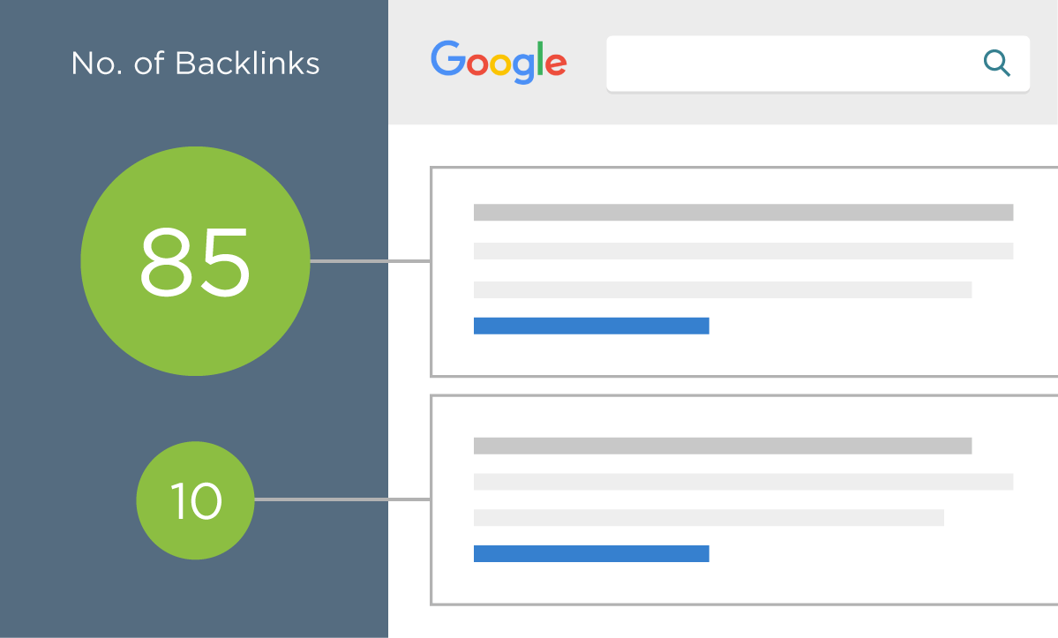
Today, the major search engines use many metrics to determine the value of external links. Some of these metrics include:
- The trustworthiness of the linking domain.
- The popularity of the linking page.
- The relevancy of the content between the source page and the target page.
- The anchor text used in the link.
- The number of links to the same page on the source page.
- The number of root domains that link to the target page.
- The amount of variations that are used as anchor text to links to the target page.
- The ownership relationship between the source and target domains.
In addition to these metrics, external links are important for two main reasons:

Popularity
Whereas traffic is a "messy" metric and difficult for search engines to measure accurately (according to Yahoo! search engineers), external links are both a more stable metric and an easier metric to measure. This is because traffic numbers are buried in private server logs while external links are publicly visible and easily stored. For this reason and others, external links are a great metric for determining the popularity of a given web page.

Relevancy
Links provide relevancy clues that are tremendously valuable for search engines. The anchor text used in links is usually written by humans (who can interpret web pages better than computers) and is usually highly reflective of the content of the page being linked to. Many times this will be a short phrase (e.g., "best aircraft article") or the URL of the target page (e.g., http://www.best-aircraft-articles.com).

The target and source page, as well as the domain cited in a link also provide valuable relevancy metrics for search engines. Links tend to point to related content. This helps search engines establish knowledge hubs on the Internet that they can then use to validate the importance of a given web document.

Ahrefs
We use a premium tool called Ahrefs to get insight into your backlink profile. Every website is given an Ahrefs Rank, UR and DR:

Ahrefs Rank (AR) shows the target website's position among all other websites in our database rated by the "strength" of their backlink profiles. The website with the strongest backlink profile is ranked #1.

URL Rating (UR) shows the strength of the target URL's backlink profile on a 100-point logarithmic scale Both internal and external links influence this metric.

UR has a clear positive correlation with Google rankings, meaning that high-UR pages tend to rank higher in the organic search results. When the whole domain is analyzed in Site Explorer, URL Rating will be shown for the homepage.

Domain Rating (DR) shows the strength of a website's backlink profile compared to the others in the Ahrefs database on a 100-point logarithmic scale. DR is calculated based on the number of websites linking to the domain’s URLs and their backlink profile strength.

Both UR and DR scale logarithmically with higher values being better.

DATA COLLECTION: pggames.com/

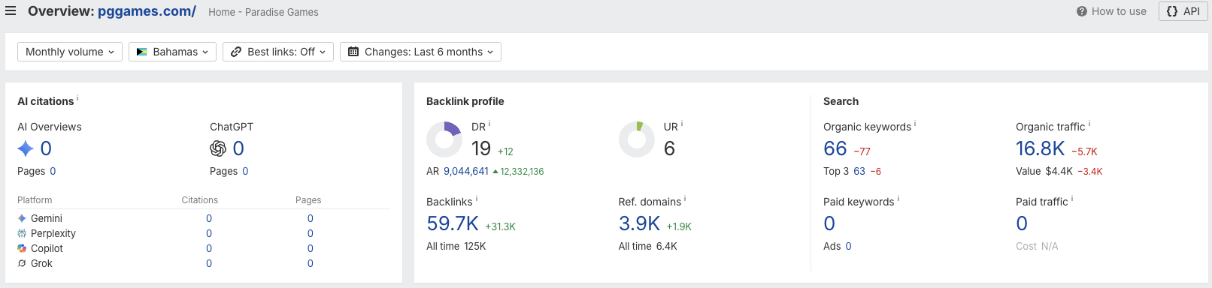

Competitors
We chose your biggest competitors in terms of data. Ie, competitors who compete for similar terms and rank the highest on Google for your target audience. While these may not be your real-life competitors, they are ranking for keywords and terms you want to rank for.

DATA COLLECTION: https://www.islandluck.com/

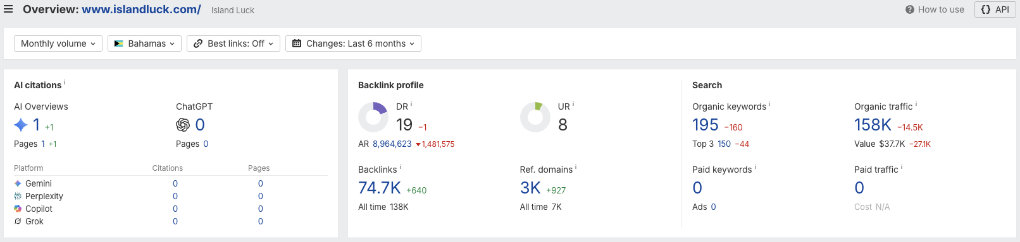

DATA COLLECTION: https://www.chancesgames.com/

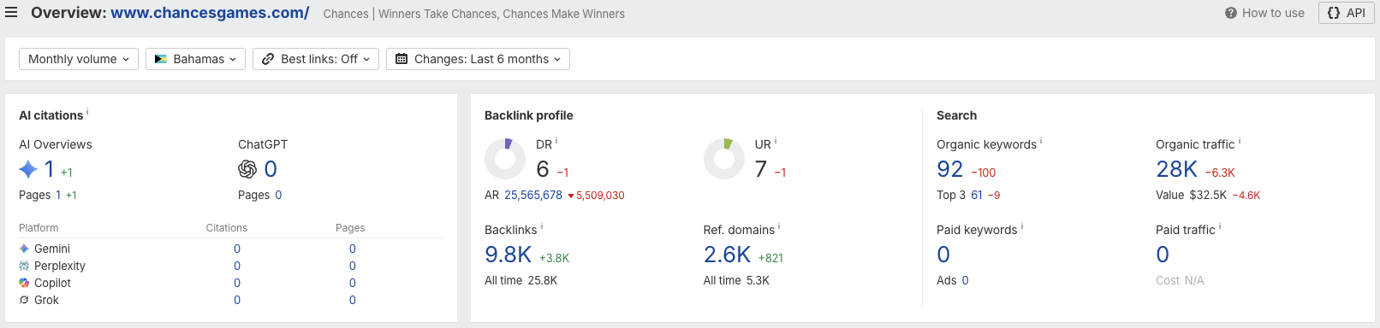

DATA COLLECTION: https://ultragames.com/

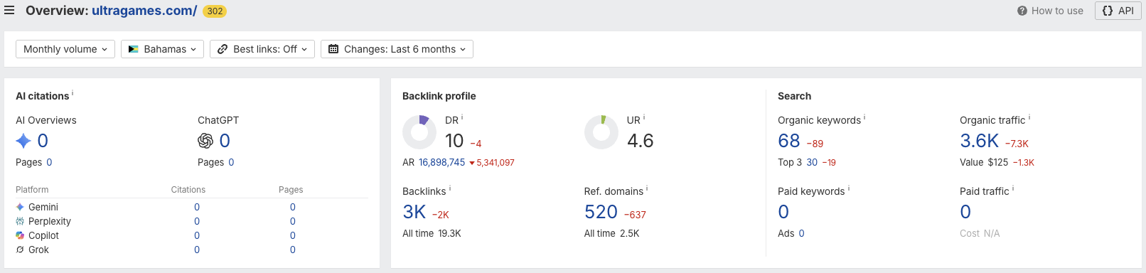

DATA COLLECTION: https://everybodywinslive.com/

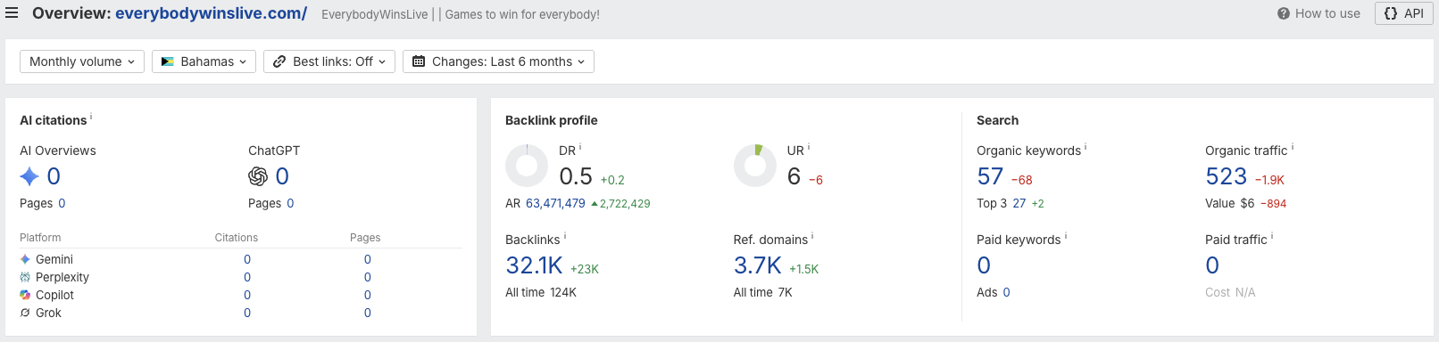

DATA COLLECTION: Referring domains over time

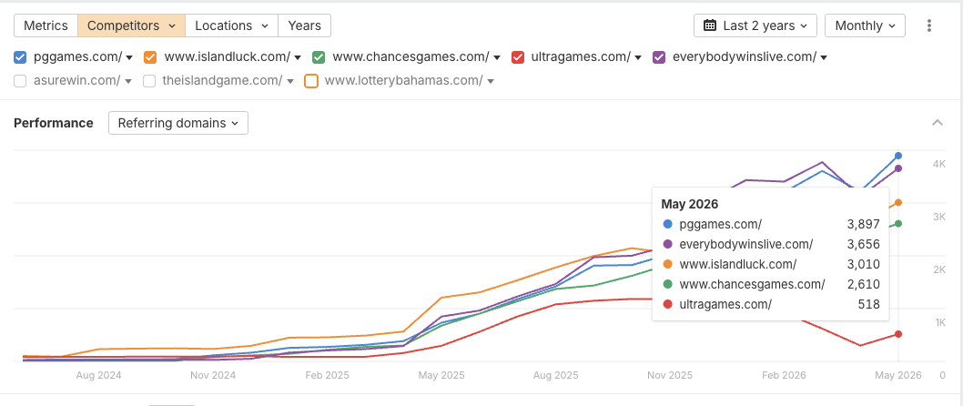

Backlinks

DATA COLLECTION

 | Backlinks
 | Backlink anchors
 | Referring domains
 | Link intersect [your competitors have these backlinks, but you don’t]

FINDINGS

- Your site has 5,497 referring domains (unique domains linking to your site).
  - 18 are high-quality domains based on a domain rating of more than 30 and monthly traffic of more than 1,000.
  - These high-quality domains have produced 216 backlinks to the site.
    - Of these, 138 are do-follow links.
    - As a general guideline, backlink costs range from around $100 to several hundred dollars, depending on the quality of the domain, its domain rating, and the backlink acquisition strategy (such as link insertion, guest posting, or digital PR).
    - The majority of your backlinks are do-follow links. The referring domains export indicated 104,974 do-follow links from 108,971 total links to target.
- Some high-quality and relevant referring domains already link to Paradise Games. These include bahamaslocal.com, bnt.bs, gamingboardbahamas.com, ournews.bs, yogonet.com, eventcaddy.com and mapcarta.com.
  - However, the backlink profile is heavily inflated by spam-marked referring domains. This means that raw backlink volume should not be treated as the main measure of authority.
- Some of your competitors have more organic visibility and comparable backlink profiles.
  - Island Luck has 74,286 backlinks and 2,485 do-follow referring domains, while Paradise Games has 59,068 backlinks and 3,125 do-follow referring domains in the competitor summary.
- Some anchor text requires improvement.
  - The anchor export includes useful branded anchors such as “www.pggames.com”, “Paradise Games”, “paradisegames.com”, and “Paradise Games Nassau”, but it also includes spam anchors such as “TELEGRAM @SEOBALAP - SEO BACKLINKS, BLACK-LINKS, TRAFFIC BOOST, LINK INDEXING” and similar black-hat SEO anchor text.
- The link intersect file shows several iGaming/casino-related domains linking to competitors but not to Paradise Games, including vegas-expert.com, kasinoguru-cz.com, casinoguru-it.com, kasinoguru-bg.com, templeofgames.com, templodeslots.net and templodeslots.es.
- N/A

RECOMMENDATIONS
- Get more quality do-follow backlinks and referring domains.
  - A do-follow backlink is a standard hyperlink that signals to search engines to follow the link, crawl the destination page, and pass authority, effectively acting as a vote of confidence that can support SEO rankings.
  - Acquire quality do-follow backlinks from relevant Bahamas publications, local directories, gaming industry sites, Caribbean entertainment sites, sports websites, responsible gaming resources, reputable iGaming directories, supplier/partner platforms, sponsorship pages and digital PR opportunities.
- Consider the content creation strategies mentioned in the content audit as a means to acquire backlinks.
- Look at the link intersect file and consider approaching sites that link to your competitors but not to you, for example:
  - vegas-expert.com - links to multiple competitors, but not Paradise Games. Review for quality and suitability before outreach.
  - kasinoguru-cz.com / casinoguru-it.com / kasinoguru-bg.com - casino-related domains linking to competitors. Review carefully, as these may be affiliate-led or region-specific.
  - templeofgames.com - links to several competitors and has meaningful traffic. Consider whether a legitimate listing or mention is possible.
  - templodeslots.net / templodeslots.es - casino-related domains linking to competitors. Review manually before outreach.
- Consider approaching local publishers, tourism/business directories, sports organisations, event partners, sponsorship partners, suppliers, affiliates, and past partners to link back to relevant Paradise Games pages.
- Consider buying citation links from legitimate local and industry directories where the listing is above board and relevant.
- Consider digital PR as a safer long-term alternative to buying backlinks, especially around brand stories, responsible gaming, community involvement, events, sponsorships, and product updates.
- Avoid building low-quality backlinks.
  - Irrelevant content: avoid backlinks from websites completely unrelated to The Bahamas, gaming, entertainment, sport, lotteries, casinos, business listings or local relevance.
  - Low-quality/spam domains: avoid backlink networks, automated link sellers, hacked-site links, low-traffic directories, and domains with obvious black-hat SEO anchor text.
- Try to ensure a healthy mix of backlink anchors.
  - Branded anchors: Paradise Games, pggames.com, www.pggames.com.
  - Partial-match anchors: Paradise Games Bahamas, Paradise Games Nassau, Paradise Games locations.
  - Service/topic anchors: Bahamas lotto results, Bahamas winning numbers, online casino Bahamas, sportsbook Bahamas, casino games Bahamas, NFL betting, NBA betting, Premier League betting, etc.
- Avoid overusing exact-match commercial anchors, as this can look unnatural when done at scale.

Google My Business
An important first step in any local SEO strategy is to claim and verify your local business’s Google My Business (GMB) listing. Getting on Google My Business can increase your chances of showing up in Google’s Local Pack, Local Finder, Google Maps, and organic rankings in general.

Qualifying local businesses can claim a free listing on Google and include information about their company, such as their address, phone number, business hours, and types of payment accepted.

Additionally, over the past several months, Google has added some great features to Google My Business that companies should take advantage of to enhance their listings and help grab viewers’ attention — and can increase their rankings in local search results.

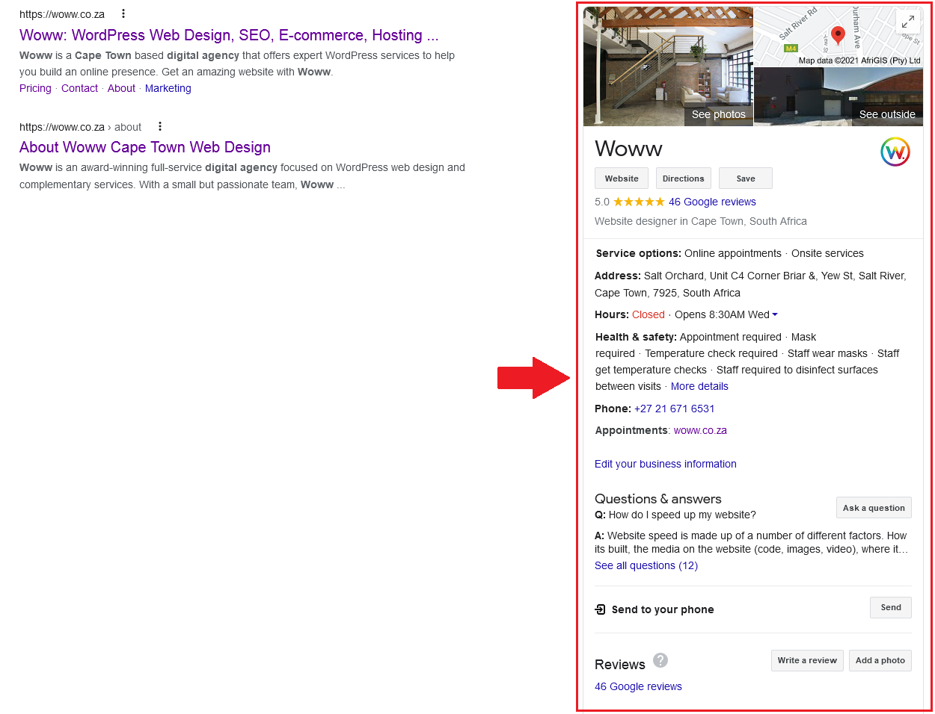
This is an example of the Woww Google My Business account. As you can see, it has useful information (such as contact info and hours) and a 5-star rating with a fair number of reviews.
FINDINGS

- Google Business Profiles are set up.
- Paradise Games has 20 Google Business Profiles (listed in the competitor analysis).
- Website, address, hours, and phone number appear to be present.
- The reviewed profile has an average rating of 4.1 stars.
- Social media links are present.
- The reviewed profile has only 8 reviews (HQ profile). Profile with most reviews has 67 reviews and a 4-star rating.
  - Competitors may have stronger review signals:
  - Island Luck has 340 reviews.
  - Chances Games has 22 reviews.
  - Ultra Games has 20 reviews.
  - EverybodyWinsLive has 20 reviews.
- Only 7 photos are listed for the reviewed Paradise Games HQ profile.
  - Island Luck has approximately 15-20 photos, which gives users more visual trust signals.
- Paradise Games has a broad local footprint, but its review count is low compared with the number of Google Business Profiles and Island Luck.
- This means Paradise Games may be underusing a strong competitive advantage in terms of optimisation: its physical presence across The Bahamas.

RECOMMENDATIONS
- Continue collecting positive reviews from satisfied customers by actively requesting feedback after a positive experience.
- Create a structured review-generation process across all Paradise Games locations.
- Prioritise the profiles with the fewest reviews first.
- Ensure negative reviews are responded to quickly and professionally.
- Add more photos to each profile, including storefronts, staff, interiors, signage, products/services, promotions, and location-specific images.
- Add or improve product/service listings where relevant.
- Consider adding Google Q&A content if this has not already been done.
- Consider making Google posts for updates, offers, events, responsible gaming messaging, branch updates, and product/service announcements.
- Standardise profile information across all locations, including business name, business description, address, phone number, opening hours, website links, and service information.
- Use the website to support the Google Business Profiles by creating or improving location pages and linking each profile to the most relevant page.


Detailed Competitor Analysis
lDETAILEDl lCOMPETITORl lANALYSISl
We put together an excel spreadsheet with 3 competitors measuring a range of factors such as company size, content creation activity, social media stats, etc.
This is to give some insight in comparing companies on more than just SEO data.

 | Initial Competitor Analysis
 | Detailed Competitor Analysis

Please note: regarding the detailed competitor analysis, there is a second tab with section specific conclusions.

ANALYSIS SUMMARY: https://pggames.com/
- Paradise Games has an 11 year old domain, registered on 4 June 2015.
- Paradise Games does not appear to maintain a blog.
- On-page SEO is currently poor to below-average. The competitor analysis notes limited crawlable text, limited heading structure, and limited/no dedicated pages for different games.
  - Some of the most important pages could benefit from more relevant keywords in the meta titles, descriptions, H1s, and subheadings. This aligns with the Content Audit, which found that the homepage is carrying too much SEO responsibility.
  - The site would benefit from clearer dedicated landing pages for major search intents such as Lotto, Results, Casino, Sportsbook, Sign Up, locations/deposit information, game types, and responsible gaming.
  - The heading/H structure of key pages can be improved with strategic and hierarchical H-tagging from H1 to H2, H3, and H4.
- Some pages would benefit from more crawlable supporting content, especially pages targeting high-intent searches such as winning numbers, casino games, online casino Bahamas, and sportsbook-related searches.
- Some images are missing or have weak alt text, according to the Content Audit.
- Paradise Games has 20 Google Business Profiles.
- The reviewed Google Business Profile has 8 reviews, a 4.1 rating, and 7 images.
- There is no email opt-in offer.
- Paid ads traffic and ad keywords data were not found.
- SEO metrics:
- SEO metrics: Paradise Games typically does the 3rd best of the competitors.
  - 19,098 monthly traffic (3rd best)
  - 3,765 referring domains (1st best)
  - 68 keywords in the top 10 positions (3rd best)
  - DR 19 (joint 1st best)
  - 59,068 backlinks (2nd best)
- Paradise Games has a strong backlink footprint in terms of volume, but the referring domains export shows that a large portion of the backlink profile is marked as spam. The priority should be improving backlink quality rather than increasing raw backlink volume.

ANALYSIS SUMMARY: https://www.islandluck.com/
- Island Luck’s domain is 17 years old and was registered on 18 December 2008.
- Island Luck does not appear to maintain a blog.
- On-page SEO is below average/poor.
  - The homepage has better crawlable content depth than Paradise Games, and dedicated pages exist for key services.
  - Some pages could benefit from more relevant keywords in the meta title, description, and subheadings.
  - The heading/H structure of key pages can be improved with strategic and hierarchical H-tagging from H1 to H2, H3, and H4.
- A Google Business Profile exists and has 340 reviews, a 4.1 rating, and approximately 15-20 images.
- There is no email opt-in offer.
- Paid ads traffic and ad keywords were not found.
- SEO metrics: Island Luck typically does the best of the competitors.
  - 175,156 monthly traffic (1st best)
  - 2,922 referring domains (3rd best)
  - 193 keywords in the top 10 positions (2nd best)
  - DR 19 (joint 1st best)
  - 74,286 Backlinks (1st best)

ANALYSIS SUMMARY: https://www.chancesgames.com/
- Chances Games has a 13-14 year old domain, registered on 6 September 2012.
- Chances Games does not appear to maintain a blog.
- On-page SEO is below average/poor.
  - Content depth and crawlable text are stronger than Paradise Games on some key pages, but there is still room for improvement.
  - Some pages could benefit from more relevant keywords in the meta title, description, and subheadings.
  - The heading/H structure of key pages can be improved with strategic and hierarchical H-tagging from H1 to H2, H3, and H4.
- A Google Business Profile exists, with 22 reviews and a 4.2 rating.
- There is no email opt-in offer.
- Paid ads traffic and ad keywords were not found.
- SEO metrics: Chances Games typically does the 2nd best of the competitors.
  - 28,046 monthly traffic (2nd best)
  - 2,545 referring domains (4th best)
  - 296 keywords in the top 10 positions (1st best)
  - DR 6 (4th best)
  - 9,396 Backlinks (4th best)

ANALYSIS SUMMARY: https://ultragames.com/
- Ultra Games has the oldest domain in the competitor set, registered on 27 December 2002 (24 years old)
- Ultra Games does not appear to maintain a blog.
- On-page SEO is okay, but still has room for improvement.
  - Meta titles could be more specific and better optimised for dedicated pages.
  - The heading/H structure of key pages can be improved with strategic and hierarchical H-tagging from H1 to H2, H3, and H4.
  - Dedicated pages exist for casino and related services.
  - Ultra Games has a locations hub, but the content appears limited.
- A Google Business Profile exists. The competitor analysis records 20 reviews and a 3.9 rating.
- There is no email opt-in offer.
- Paid ads traffic and ad keywords were not found.
- SEO metrics: Ultra Games typically does the 4th best of the competitors.
  - 5,125 monthly traffic (4th best)
  - 454 referring domains (5th best)
  - 36 keywords in the top 10 positions (5th best)
  - DR 10 (3rd best)
  - 2,725 Backlinks (5th best)

ANALYSIS SUMMARY: https://everybodywinslive.com/
- EverybodyWinsLive has a 13 year old domain, registered on 25 May 2013.
- EverybodyWinsLive does not appear to maintain a blog.
- On-page SEO is okay, but still has room for improvement.
  - Meta titles could be more specific and better optimised for dedicated pages.
  - The heading/H structure of key pages can be improved with strategic and hierarchical H-tagging from H1 to H2, H3, and H4.
  - Dedicated pages exist for lotto and casino-related services.
- A Google Business Profile exists. The competitor analysis records 20 reviews and a 4.4 rating.
- There is no email opt-in offer.
- Paid ads traffic and ad keywords were not found.
- SEO metrics: EverybodyWinsLive typically does the 5th best of the competitors.
  - 550 monthly traffic (5th best)
  - 3,561 referring domains (2nd best)
  - 57 keywords in the top 10 positions (4th best)
  - DR 0.5 (5th best)
  - 31,127 Backlinks (3rd best)

RECOMMENDATIONS
- Improve the on-page SEO and quality of key landing pages: Resolve instances of weak, missing, duplicate, or overly generic meta titles and meta descriptions. Ensure meta titles contain relevant target keywords and fall within the recommended 50-60 character range. Ensure meta descriptions are under 140 characters and contain a clear, action-oriented CTA.
- Enhance heading structures. Ensure H1s are present, relevant, and keyword-optimised. Ensure there is a consistent hierarchy in the heading structure (H1 > H2 > H3 > H4) and that it is logically organised.
- Add more crawlable supporting content to important pages. Paradise Games has a strong brand and clear commercial offering, but the site currently has limited crawlable text and limited/no dedicated pages for different games and services.
- Improve internal linking between the homepage, results pages, casino pages, sportsbook pages, lotto pages, sign-up pages, responsible gaming pages, and location/deposit information pages.
- Ensure all images have descriptive, keyword-rich alt text. Review existing alt text for optimisation opportunities. Some images are currently missing alt text, and most existing alt text can be improved.
- Create or improve dedicated landing pages: Create dedicated pages for major search intents such as lotto, winning numbers, casino, sportsbook, sign up, locations, deposit information, responsible gaming, game types, NBA betting, NFL betting, and Premier League betting.
- Ensure the best keyword variation is targeted in elements such as the H1 and meta title, and that more instances of supporting keywords are included in subheadings and body content.
- Answer queries from keyword research related to each page using a Frequently Asked Questions section.
- Improve the Results page: The Results page is one of the most important organic landing pages for Paradise Games. It should be strengthened around lottery results and winning numbers search intent.
- Add a clear H1, supporting explanatory copy, FAQs, improved metadata, and internal links to relevant lotto, sign-up, and account pages.
- Build a stronger backlink profile: Acquire quality do-follow backlinks from Bahamas publications, local directories, gaming industry sites, Caribbean entertainment sites, sports websites, responsible gaming resources, reputable iGaming directories, partner websites, sponsorship pages, and digital PR opportunities.
- Paradise Games has a large backlink footprint, but the referring domain export shows that a large proportion of referring domains are marked as spam. This means backlink quality should be prioritised over backlink volume.
  - Consider approaching sites that link to your competitors but not to you. The link intersect file includes iGaming/casino-related domains such as vegas-expert.com, kasinoguru-cz.com, kasinoguru-it.com, kasinoguru-bg.com, templeofgames.com, templodeslots.net, and templodeslots.es.
  - Review link intersect opportunities manually before outreach. Some casino and affiliate-style domains may be useful, while others may be low-quality or unsuitable from a compliance perspective.
  - Consider approaching local publishers, tourism/business directories, sports organisations, event partners, sponsorship partners, suppliers, affiliates, and past partners to link back to relevant Paradise Games pages.
  - Avoid building low-quality backlinks from irrelevant or spammy websites.
- Improve Google Business Profile performance:
  - Paradise Games has 20 Google Business Profiles, but the reviewed profile has only 8 reviews. This is low compared with Island Luck, which has 340 reviews.
  - Create a structured review-generation process across all locations.
  - Add more photos to each profile, including storefronts, staff, interiors, signage, products/services, promotions, and location-specific images.
  - Ensure each profile has accurate business information, including business name, address, phone number, opening hours, website links, and service information.
  - Consider adding Google posts for updates, offers, events, responsible gaming messaging, branch updates, and product/service announcements.
- Google Business Profile (GBP):
  - Refer to the dedicated GBP recommendations section.
- Improve social media and website-social integration:
  - Fix the broken Facebook and Instagram links in the website footer.
  - Paradise Games has a reasonable Facebook presence, but Island Luck has a much larger social footprint across Facebook, Instagram, and YouTube.
  - Use Facebook and Instagram to support results reminders, game education, promotions, responsible gaming content, branch/location updates, and short-form video.
  - Consider re-establishing or developing a YouTube presence if video assets are available. Island Luck’s YouTube channel gives it an additional brand and trust signal.
- Support SEO with technical improvements:
  - Refer to the technical audit for detailed recommendations.
  - The main technical priorities are URL consistency, redirect cleanup, broken asset fixes, mobile performance, structured data consistency, and Search Console monitoring.
  - These technical improvements will help ensure that new content and backlinks consolidate authority properly.
- Strategic context:
  - Paradise Games is in a credible competitive position, with strong branded demand, a DR of 19, and a large backlink footprint. However, Island Luck currently leads the competitor set in organic traffic, with 175,156 monthly organic visits compared with 19,098 for Paradise Games. Chances Games also leads Paradise Games in monthly organic traffic and has the highest number of keywords ranking in the top 10 positions.
Paradise Games’ strongest opportunity is to improve keyword coverage and landing page targeting. The brand already has authority and recognition, but the site needs clearer SEO pathways for lotto results, winning numbers, online casino, sportsbook, locations, deposits, sign-up, and responsible gaming searches.
With a focused SEO and content strategy, Paradise Games can improve its competitive position by strengthening on-page SEO, creating dedicated high-intent landing pages, improving Google Business Profile signals, building higher-quality backlinks, and using social media more effectively to support trust and visibility.
- Please refer to the keyword research and content ideas sections of the content audit for specific keyword targets and content opportunities.


Social Media
lSOCIAL MEDIA &l lSOCIAL SIGNALSl
Social signals are human interaction metrics on social platforms like Facebook, Twitter, LinkedIn, Reddit, Medium, etc. Some examples of social signals are: likes, dislikes, shares, votes, pins, views, etc. which commonly help to showcase popularity and affinity for a specific piece of content.

Studies have concluded that Social signals are included as a ranking factor, we outline and identify your social presence and the impact it’s having on your SEO.

SOCIAL SUMMARY:
Paradise Games: https://pggames.com/
- Social icons on site: yes, in footer, but the Facebook and Instagram links are not working
- Facebook: 7k followers; 8-24 posts/month; 2-30 engagement; creates Facebook videos; video views range 70-8.2k, with the last 10 reels mostly between 1.6k-3k views
- X/Twitter: 23 followers; no activity since 2023; 0-5 engagements
- YouTube: not found
- Instagram: 510 followers; 8-20 posts/month; 1-20 engagements
- LinkedIn: 662 followers; 2-5 posts/month; 1-5 engagements

SOCIAL SUMMARY:
Island Luck: https://www.islandluck.com/
- Social icons on site: yes
- Facebook: 37k followers; 30-40 posts/month; 5-10 engagement; creates Facebook videos; video views usually 800-1.5k, range 800-4k
- X/Twitter: 360 followers; last active 2017; 0-5 engagements
- YouTube: 10.2k subscribers; 179 videos; 613,782 total views; infrequent updates, a few videos/year; all videos over 100 views
- Instagram: 17.3k followers; 2-4 posts/day, minimum 60/month; 1-20 engagements
- LinkedIn: 4k followers; 1-3 posts/month; usually 20-50 engagements, sometimes 7-10

SOCIAL SUMMARY:
Chances Games: https://www.chancesgames.com/
- Social icons on site: yes, in footer but not linked
- Facebook: 9.5k followers; 3 posts/month; 1-5 engagement; creates Facebook videos; video views usually 600-2k, range 600-8k
- X/Twitter: not found
- YouTube: 24 subscribers; 27 videos; infrequent updates, a few videos/year; some reels over 100 views, no long-form videos over 100 views
- Instagram: not found
- LinkedIn: not found

SOCIAL SUMMARY
Ultra Games: https://ultragames.com/
- Social icons on site: yes
- Facebook: 593 followers; last active Sep 2025; 0-5 engagement; creates Facebook videos; video views 30-100
- X/Twitter: not found
- YouTube: 592 subscribers; 60 videos; 50,621 total views; infrequent updates, a few videos/year; all videos over 100 views
- Instagram: 666 followers; around 10 posts/month; 0-5 engagements
- LinkedIn: not found

SOCIAL SUMMARY:
EverybodyWinsLive: https://everybodywinslive.com/
- Social icons on site: Twitter, Facebook, Instagram
- Facebook: 1.1k followers; approx. 10 posts/month; 0-5 engagement; creates Facebook videos; video views 50-250
- X/Twitter: 59 followers; last active May 2024; 0-5 engagements
- YouTube: not found
- Instagram: 2,410 followers; 6-10 posts/month; 0-5 engagements
- LinkedIn: 231 followers; last posted 1 year ago; 1-5 engagements

RECOMMENDATIONS
- Fix social media links on the website. Paradise Games has Facebook and Instagram icons in the footer, but the workbook notes that these links are not working. This should be treated as a priority, as active social channels are currently being missed from the website user journey.
- Maintain and refine Facebook posting frequency. Paradise Games is already posting around 8-24 times per month on Facebook, with 7k followers and video views ranging from 70 to 8.2k. This is a strong foundation, although Island Luck leads the category with 37k followers and 30-40 posts per month. Paradise Games should continue posting consistently, with more focus on high-performing video formats, promotions, results content, winner announcements, and game education.
- Improve Facebook engagement quality. Current Facebook engagement is relatively modest at around 2-30 engagements per post. Paradise Games should test more interactive formats such as polls, jackpot reminders, prize countdowns, short reels, winner-led posts, and comments-driven prompts to increase reach and response rates.
- Continue growing Instagram activity. Paradise Games has 510 Instagram followers and appears to post around 8-20 times per month. This is a healthy posting rhythm, but Island Luck is significantly ahead with 17.3k followers and a minimum of around 60 posts per month. Instagram should be used more aggressively for reels, results reminders, game highlights, promotional creatives, winner content, and behind-the-scenes retail/location content.
- Prioritise short-form video across Facebook and Instagram. Paradise Games’ Facebook reels are already showing potential, with recent videos often reaching 1.6k-3k views. This suggests short-form video is one of the strongest social opportunities. Repurpose top-performing reels across both Facebook and Instagram to maximise reach without creating entirely separate content streams.
- Reactivate or archive Twitter/X. Paradise Games has 23 followers on X and no activity since 2023. Most competitors are also inactive or low-performing on X, so this should remain a low-priority channel. Either reactivate it with 2-4 posts per month for major updates, results, and promotions, or remove the X icon from the website if it is not part of the ongoing social strategy.
- Create or relaunch a YouTube presence. No Paradise Games YouTube channel was found in the workbook, while Island Luck has 10.2k subscribers, 179 videos, and 613,782 total views. YouTube represents a clear competitor gap. Paradise Games should create a channel for game explainers, app walkthroughs, promotion recaps, winner stories, responsible gaming content, and evergreen “how to play” videos.
- Strengthen LinkedIn for brand authority and recruitment. Paradise Games has a LinkedIn presence with 201-500 employees listed and 70 associated members, while the social section records 662 followers and 2-5 posts per month. LinkedIn should be used to support employer branding, corporate announcements, community initiatives, partnerships, retail expansion, and responsible gaming messaging.
- Correct the LinkedIn URL in the audit/workbook. The workbook’s LinkedIn URL row appears to contain an old PowerPlastics link for Paradise Games. This should be replaced with the Paradise Games LinkedIn URL listed elsewhere in the workbook.
- Use a social scheduling tool to maintain consistency. Tools such as Buffer, Hootsuite, or Meta Business Suite should be used to schedule Facebook, Instagram, LinkedIn, and future YouTube content, ensuring promotions, results, and campaign posts are published consistently.
- Prioritise Facebook, Instagram, and YouTube as the main social channels. These platforms offer the strongest opportunity for Paradise Games’ audience, especially for visual promotions, game education, winner-led content, short-form video, and traffic back to key product or results pages.


Summary and Conclusion
lSUMMARY &l lCONCLUSIONl

Summary and Conclusion
Paradise Games has a strong established brand in The Bahamas, with meaningful branded search demand, 19,098 estimated monthly organic visits, and a large backlink footprint. The site ranks strongly for core branded terms such as "paradise games" and "pggames", and it has clear existing authority in the lottery, casino, results, and gaming space.

However, the competitive data shows that Paradise Games is not currently leading the market across organic visibility. Island Luck is the strongest competitor in the set, with 175,156 estimated monthly organic visits, a larger social following, and a more developed YouTube presence. Chances Games also outperforms Paradise Games on organic traffic, while Ultra Games and EverybodyWinsLive provide useful benchmarks across product positioning, social activity, and local visibility.

The key opportunity for Paradise Games is to turn its existing brand strength into broader non-branded organic reach. This means improving keyword coverage around lotto results, winning numbers, online casino, sportsbook, sign-up, deposits, locations, responsible gaming, and individual game or betting categories. Dedicated landing pages, stronger page copy, optimised metadata, clear heading structures, FAQs, and improved internal linking will help the site compete for more high-intent searches instead of relying heavily on the homepage and branded demand.

The backlink profile is large, but quality needs to be prioritised over volume. The referring domains export shows 5,497 referring domains, but a large proportion of the profile is inflated by spam-marked domains and poor-quality anchor text. Paradise Games should focus on acquiring relevant, legitimate do-follow links from Bahamas publications, local directories, sports and entertainment sites, iGaming resources, sponsorship partners, responsible gaming resources, and high-quality competitor link intersect opportunities.

From a technical and content perspective, the main priorities are to clean up crawl and indexation signals, improve metadata, strengthen H1 and heading structures, add crawlable supporting content, fix broken resources, refine redirects, improve image alt text, and support important pages with better internal links. These improvements will make the site easier for search engines to understand and will give key commercial and informational pages a stronger chance of ranking.

Social media is also an important growth area. Paradise Games is active on Facebook and Instagram, but competitors, especially Island Luck, have a much larger audience and stronger video presence. Fixing broken website social links, continuing short-form video production, improving engagement, reactivating or archiving X, developing a YouTube presence, and using LinkedIn for brand authority will strengthen Paradise Games' broader digital footprint.

In summary, Paradise Games is in a credible competitive position, but there is significant room to grow. The brand already has recognition, search demand, backlinks, and active social channels. The next phase should focus on converting that foundation into stronger SEO performance through better landing pages, richer content, cleaner technical signals, higher-quality links, improved Google Business Profile activity, and a more strategic social media presence.

Areas for Improvement
Here, we will discuss the sections of this audit and the actions we recommend to address the problems.

Off Page
OFF PAGE | 10+ suggested actions
Actions suggested:

- Get more quality do-follow backlinks and referring domains.
  - Prioritise quality over volume. Paradise Games already has a large backlink footprint, but the referring domain export shows that many referring domains are marked as spam.
  - Focus on links from domains that are relevant to The Bahamas, gaming, lotto, casino, sports, entertainment, tourism, local business, events, and responsible gaming.
  - Prioritise domains with real organic traffic and a clean backlink profile.
- Acquire quality do-follow backlinks from relevant websites and organisations.
  - Bahamas publications and news sites.
  - Local business directories.
  - Tourism and entertainment websites.
  - Sports organisations and sports media.
  - Gaming and casino industry publications.
  - Responsible gaming resources.
  - Event partners and sponsorship pages.
  - Supplier, affiliate, or partner websites.
  - Reputable iGaming directories and review sites.
- Use the link intersect file to identify backlink opportunities.
  - Review sites that link to competitors but not to Paradise Games.
  - Potential examples from the link intersect file include:
    - vegas-expert.com
    - kasinoguru-cz.com
    - kasinoguru-it.com
    - kasinoguru-bg.com
    - templeofgames.com
    - templodeslots.net
    - templodeslots.es
  - Manually review each site before outreach to confirm quality, relevance, traffic, and compliance suitability.
- Avoid low-quality backlink acquisition.
  - Avoid automated backlink sellers.
  - Avoid hacked-site links.
  - Avoid spam directories.
  - Avoid irrelevant foreign domains with no topical connection.
  - Avoid sites with high DR but no meaningful organic traffic.
  - Avoid anchors that look like black-hat SEO link selling.
- Improve backlink anchor text quality.
  - Build a natural mix of branded, partial-match, URL, and topic-based anchors.
  - Branded anchors: Paradise Games, pggames.com, www.pggames.com.
  - Partial-match anchors: Paradise Games Bahamas, Paradise Games Nassau, Paradise Games locations.
  - Topic anchors: Bahamas lotto results, Bahamas winning numbers, online casino Bahamas, sportsbook Bahamas, casino games Bahamas.
  - Avoid overusing exact-match commercial anchors at scale.
- Build links to the most important organic landing pages.
  - Homepage.
  - Results page.
  - Lotto pages.
  - Casino pages.
  - Sportsbook pages.
  - Sign-up/account pages.
  - Location/deposit information pages.
  - Responsible gaming pages.
- Use content creation as a backlink acquisition strategy.
  - Create useful assets that other websites may reference.
  - Examples include guides around lotto results, winning numbers, responsible gaming, sports betting basics, casino game explainers, and location/deposit information.
  - Promote these assets through outreach rather than relying only on publishing.
- Strengthen local authority.
  - Seek links from Bahamas-based websites and organisations.
  - Approach local publishers, event partners, sponsorship partners, business directories, tourism websites, and sports/community organisations.
  - Ensure Paradise Games is listed consistently in relevant local directories.
- Improve Google Business Profile signals.
  - Paradise Games has 20 Google Business Profiles, but the reviewed profile has only 8 reviews.
  - Create a structured review-generation process across all locations.
  - Add more photos to each profile.
  - Keep business name, address, phone number, hours, website links, and service information consistent.
  - Consider Google posts for updates, offers, events, responsible gaming messaging, and branch updates.
- Monitor the backlink profile regularly.
  - Review new referring domains periodically.
  - Watch for spikes in spam links or black-hat anchor text.
  - Do not disavow links automatically, but investigate suspicious patterns if rankings or Search Console signals are affected.
  - Keep a record of high-quality links acquired through outreach, PR, partnerships, and directories.

Competitors
COMPETITORS | 10+ suggested actions
- Improve the overall quality and on-page SEO of key landing pages.
  - Paradise Games has a strong brand and commercial offering, but competitors currently have stronger organic visibility and clearer page targeting in some areas.
  - Resolve weak, missing, duplicate, or overly generic meta titles and meta descriptions.
  - Ensure meta titles contain target keywords and fall within the recommended 50-60 character range.
  - Ensure meta descriptions are under 140 characters and include a clear, action-oriented CTA.
- Improve heading structures across key pages.
  - Ensure every important page has a clear, keyword-relevant H1.
  - Use a logical heading hierarchy: H1 > H2 > H3 > H4.
  - Add relevant subheadings to improve readability and keyword coverage.
  - Prioritise the homepage, Results page, Casino page, Sportsbook page, Lotto pages, Sign Up page, and location/deposit information pages.
- Create or improve dedicated landing pages for major search intents.
  - Lotto.
  - Winning numbers.
  - Results.
  - Online casino Bahamas.
  - Casino games.
  - Sportsbook Bahamas.
  - NBA betting.
  - NFL betting.
  - Premier League betting.
  - Sign up / account creation.
  - Deposits and locations.
  - Responsible gaming.
- Use Island Luck as the main organic search benchmark.
  - Island Luck has the highest estimated organic traffic in the competitor set.
  - Review Island Luck’s site structure, service coverage, local presence, and social visibility for ideas that can be adapted.
  - Do not copy content directly; use the competitor review to identify gaps in Paradise Games’ own page structure and content coverage.
- Use Chances Games as a keyword coverage benchmark.
  - Chances Games has the highest number of keywords ranking in the top 10 positions.
  - This suggests Paradise Games can improve visibility through better keyword targeting, not only through more backlinks.
  - Review where Chances Games ranks for high-intent lotto, results, and casino-related searches.
- Improve the Results page.
  - The Results page is one of Paradise Games’ most important organic landing pages.
  - Strengthen it around lottery results and winning numbers search intent.
  - Add a clear H1, supporting explanatory copy, FAQs, improved metadata, and internal links to relevant lotto, sign-up, and account pages.
  - Make the page more useful for users looking for current and past winning numbers.
- Use the homepage as a gateway, not the only SEO landing page.
  - The homepage should introduce the main Paradise Games services.
  - Link clearly to Lotto, Results, Casino, Sportsbook, Sign Up, locations/deposit information, and Responsible Gaming.
  - Avoid relying on the homepage to rank for every keyword theme.
- Improve crawlable content depth on important pages.
  - Add concise supporting copy that explains each product/service clearly.
  - Include useful FAQs where keyword research shows relevant questions.
  - Add internal links to related pages.
  - Avoid adding generic filler content; the copy should answer real user questions and support conversion.
- Build out location and local-intent content.
  - Paradise Games has a broader local footprint than the current website appears to leverage.
  - Create or improve location-focused pages where appropriate.
  - Include location-specific information, opening hours, services, deposit/account information, and links to relevant Google Business Profiles.
  - Use these pages to support local rankings and GBP performance.
- Improve internal linking across the site.
  - Link from the homepage to priority service pages.
  - Link from Results pages to Lotto and Sign Up pages.
  - Link from Casino and Sportsbook pages to relevant account/deposit and responsible gaming pages.
  - Use descriptive anchor text rather than generic anchors where possible.
- Align content work with the completed Content Audit.
  - Use the keyword research and content ideas from the Content Audit to decide which pages should be created or expanded first.
  - Prioritise pages with commercial or high-intent search demand.
  - Avoid creating low-value blog content unless it supports clear search demand, backlinks, or user education.
- Support competitor gains with technical cleanup.
  - Refer to the Technical Audit for detailed recommendations.
  - Fix URL consistency issues.
  - Reduce avoidable redirects.
  - Fix broken assets.
  - Improve mobile performance.
  - Continue monitoring Search Console as more data becomes available.
- Improve Google Business Profile and local trust signals.
  - Paradise Games has 20 Google Business Profiles, but the reviewed profile has only 8 reviews.
  - Island Luck has a much stronger review profile.
  - Review generation, profile photos, Google posts, and consistent business information should be improved across locations.
- Use social media to support competitor positioning.
  - Paradise Games has a reasonable Facebook presence, but Island Luck has a much stronger social footprint.
  - Fix broken Facebook and Instagram links on the website.
  - Use social posts to support results reminders, game education, branch/location updates, responsible gaming content, and promotions.
- Track competitor movement over time.
  - Monitor organic traffic.
  - Monitor keywords ranking in the top 10 positions.
  - Monitor referring domains and backlink quality.
  - Monitor branded search demand.
  - Monitor Google Business Profile reviews and ratings.
  - Monitor social media activity and engagement.

Social Media
SOCIAL MEDIA | 9 suggested actions
You’re active on certain social media platforms, but you should still work on improving engagement.

Actions suggested:

- Fix the social media links on the website.
  - The competitor analysis notes that Facebook and Instagram icons are present in the footer, but the links are not working.
  - Ensure all active social icons link to the correct live profiles.
  - Remove or hide links to inactive profiles if they are not going to be maintained.
- Prioritise Facebook and Instagram as the main social channels.
  - Paradise Games has around 7k Facebook followers.
  - Paradise Games has around 510 Instagram followers.
  - Island Luck is significantly stronger, with around 37k Facebook followers and 17.3k Instagram followers.
  - Facebook and Instagram should be used consistently to build visibility, trust, and repeat engagement.
- Increase Facebook activity and consistency.
  - Paradise Games currently posts around 8-24 times per month.
  - Continue regular posting, but make sure posts are strategically tied to business goals.
  - Use Facebook for results reminders, game updates, promotions, branch/location updates, responsible gaming content, and community posts.
  - Track which post types generate the most engagement and repeat the formats that work.
- Grow Instagram activity and quality.
  - Paradise Games has a much smaller Instagram following than Island Luck and EverybodyWinsLive.
  - Use Instagram for short-form video, promotional graphics, winner/result reminders, branch/location content, and trust-building content.
  - Maintain a consistent visual style so the brand feels recognisable.
  - Use stories and reels where relevant.
- Consider building or re-establishing a YouTube presence.
  - A Paradise Games YouTube channel was not found in the competitor analysis.
  - Island Luck has a YouTube channel with 10.2k subscribers and 179 videos.
  - Ultra Games has 592 subscribers and 60 videos.
  - YouTube can support trust, brand awareness, and content reuse across the website and social platforms.
  - Possible video topics include game explainers, how to check results, how to sign up, responsible gaming, branch/location explainers, and campaign videos.
- Improve LinkedIn activity and accuracy.
  - Paradise Games has a LinkedIn profile with 662 followers.
  - The competitor analysis notes 2-5 LinkedIn posts per month.
  - Continue posting company updates, hiring posts, community involvement, sponsorships, responsible gaming content, and brand news.
  - Ensure the correct LinkedIn profile is linked from the website if LinkedIn is included as a social channel.
- Reactivate or archive X/Twitter.
  - Paradise Games has an X/Twitter profile with 23 followers.
  - The competitor analysis notes no activity since 2023.
  - Either commit to regular posting or remove X/Twitter from the website/social icon set.
  - If reactivated, use it mainly for quick updates, results reminders, customer service routing, and campaign announcements.
- Syndicate important website content across social platforms.
  - Share new or improved landing pages, guides, FAQs, results resources, responsible gaming content, and promotions across Facebook, Instagram, LinkedIn, and YouTube where relevant.
  - Use social media to send users back to priority pages on the site.
  - This will help maximise the value of SEO and content work.
- Use social media to support local SEO.
  - Post location-specific updates.
  - Highlight branch information, opening hours, events, staff, and local community involvement.
  - Encourage users to leave Google reviews after positive interactions.
  - Use social channels to support the Google Business Profile improvement work.
- Develop a content calendar.
  - Plan recurring posts around lotto/results reminders, casino/game education, sportsbook topics, promotions, responsible gaming, branch/location content, community involvement, and seasonal events.
  - Maintain a consistent posting cadence across priority channels.
  - Use social media management tools such as Buffer or Hootsuite to schedule posts and maintain consistency.
- Track social performance.
  - Monitor follower growth.
  - Monitor engagement rate.
  - Monitor reach and video views.
  - Monitor link clicks to the website.
  - Monitor which posts lead to sign-ups, account actions, or page visits where tracking is available.
  - Use these insights to refine future posting.

References and resources

lREFERENCES &l lRESOURCESl
This audit is made possible due to the research and efforts of Google and the SEO community.
Here are a number of incredible tools, articles and resources that we used to develop and perform this audit.

https://www.digicert.com/ssl/
https://analytics.google.com
https://search.google.com
https://tools.pingdom.com/
https://gtmetrix.com/
https://www.webpagetest.org/
https://transparencyreport.google.com
https://yoast.com/
https://yoast.com/meta-descriptions/
https://sitecheck.sucuri.net
https://ahrefs.com/
http://www.copyscape.com/
https://www.gotchseo.com/seo-audit/
https://neilpatel.com/blog/seo-website-audit/
https://backlinko.com/google-ranking-factors
https://backlinko.com/seo-site-audit
https://backlinko.com/on-page-seo
https://backlinko.com/link-building-strategies
https://www.searchenginejournal.com/the-ultimate-seo-audit-checklist/
https://www.thehoth.com/blog/google-medic-update/
https://barracuda.digital/panguin-seo-tool/
https://www.reliablesoft.net/seo-checklist/
https://www.google.com/business.

